1)INTEGER TO ROMAN NUMBERS

CODE

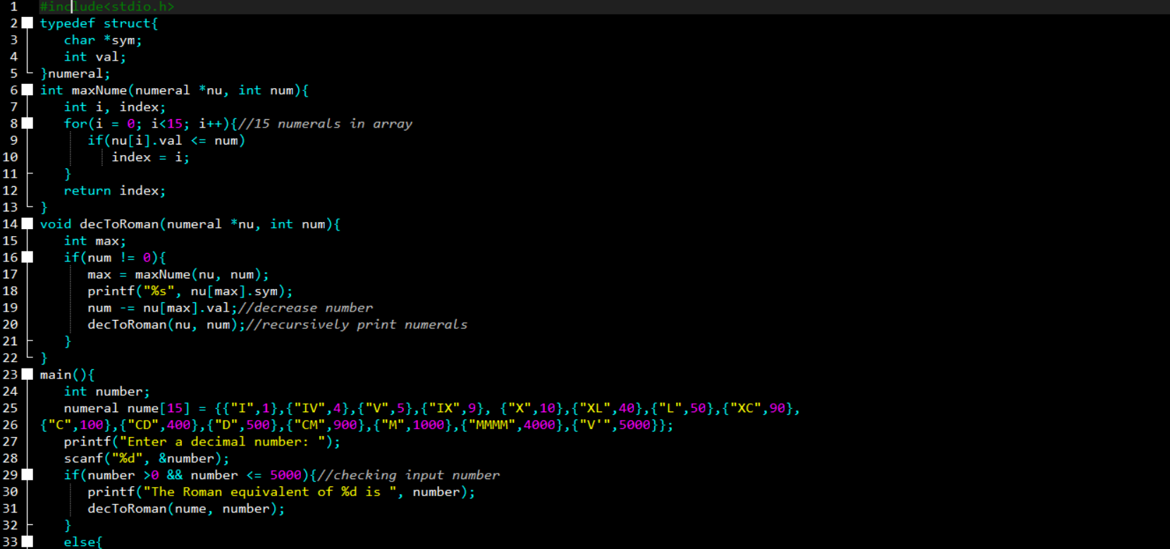

OUTPUT

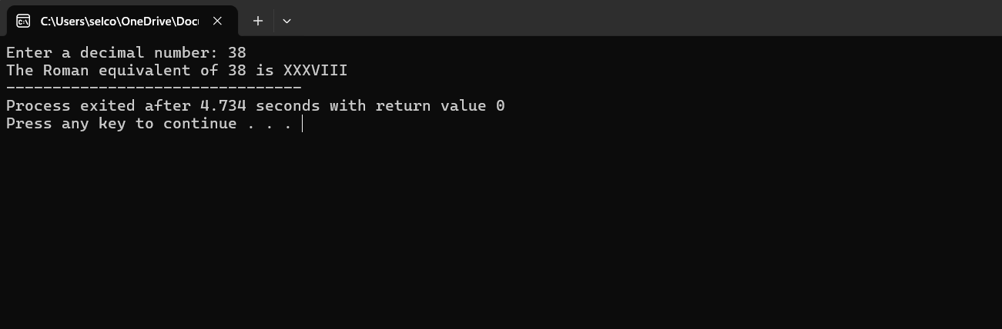

2)ROMAN NUMBERS TO INTEGER  
CODE:

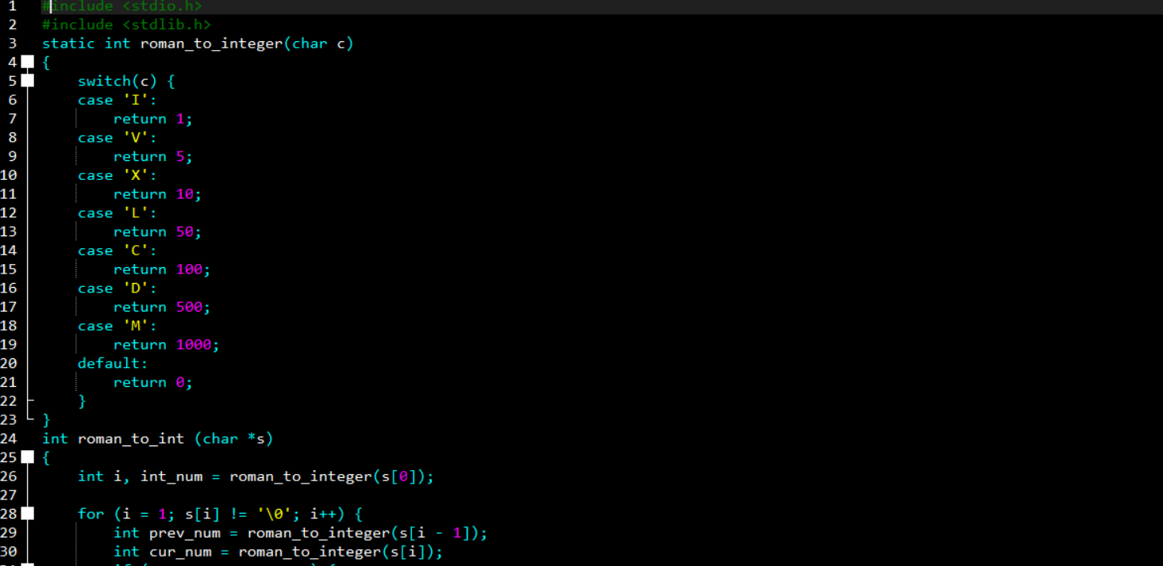

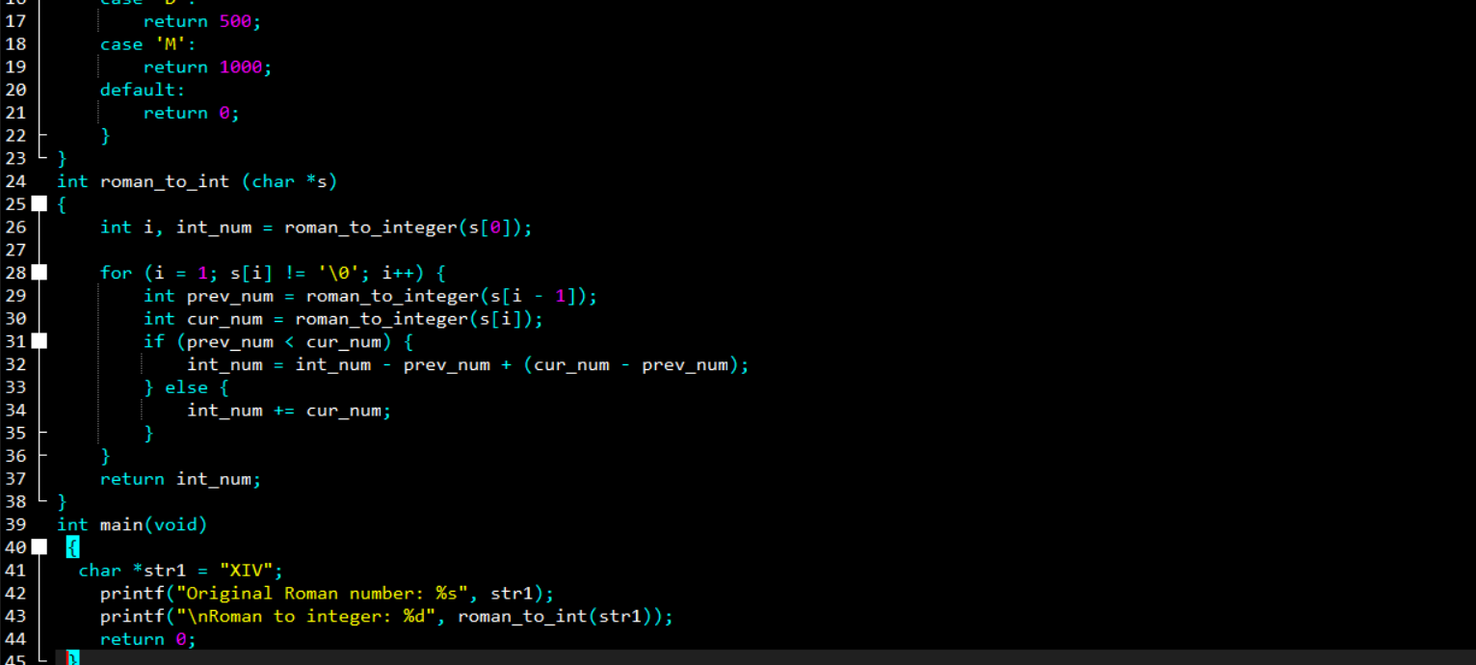

OUTPUT

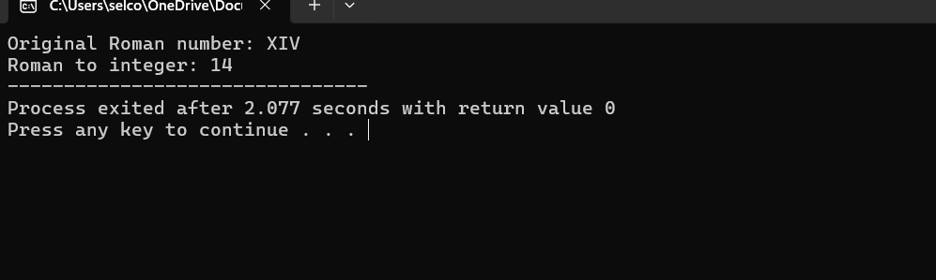

3)COMMON PREFIX

CODE:

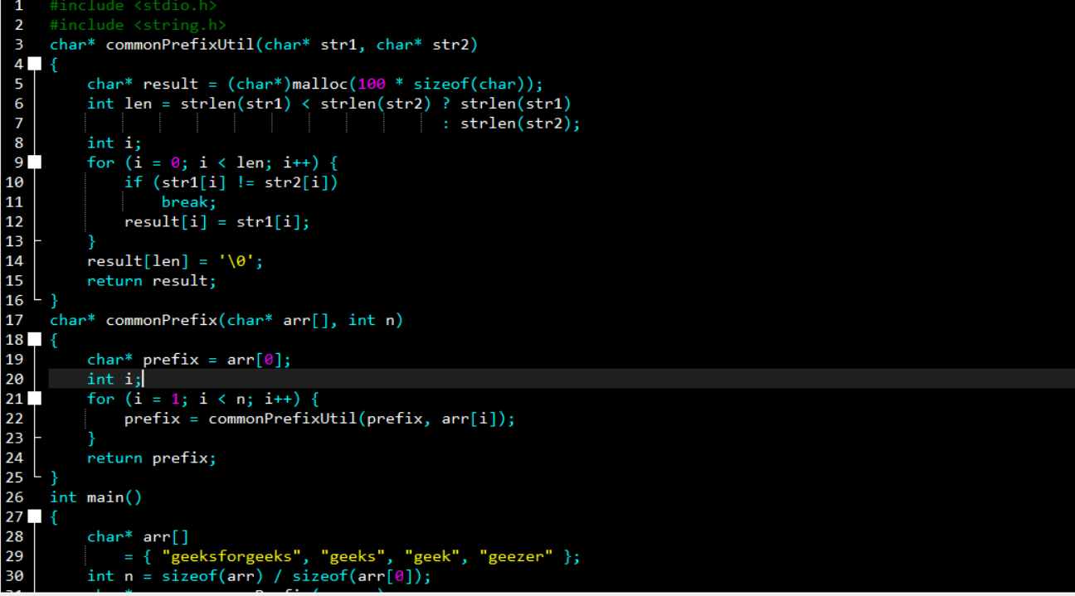

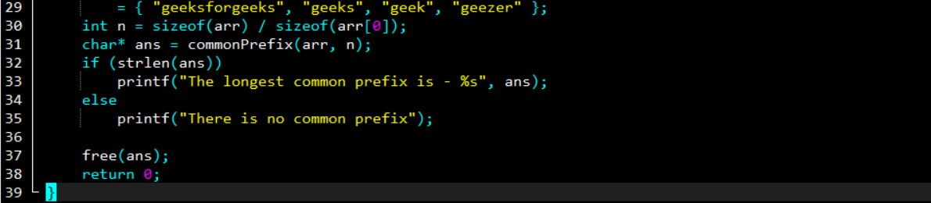

OUTPUT

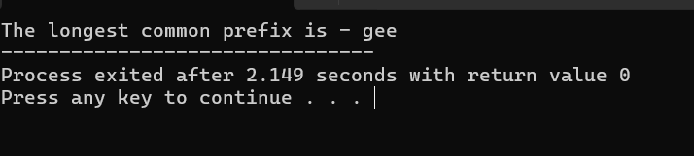

4)3 SUM IN ARRAY OF INTEGERS

CODE

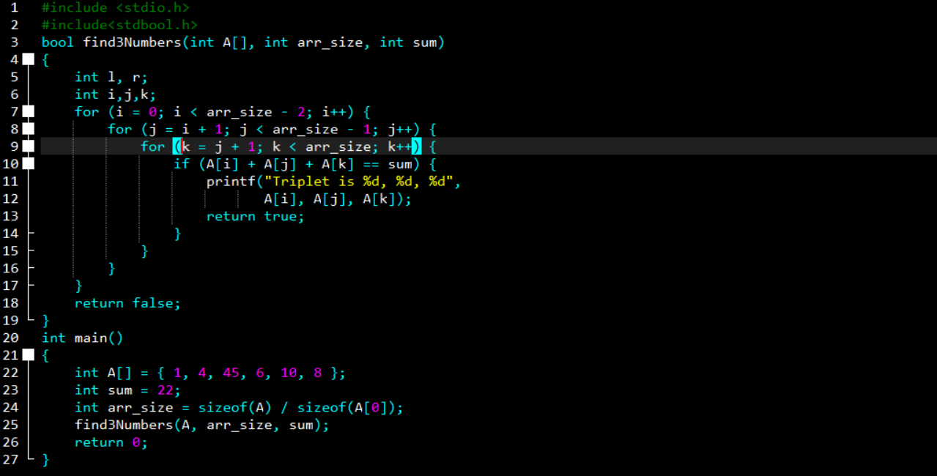

OUTPUT:

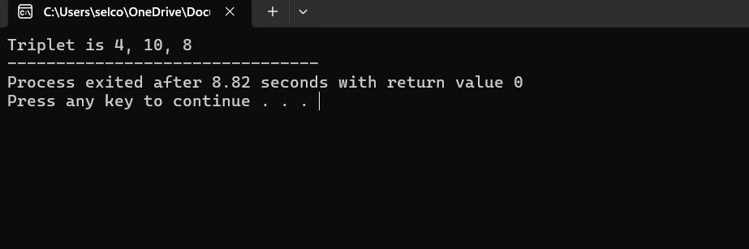

5)LETTER MAPPING TO A PHONE NUMBER

CODE:

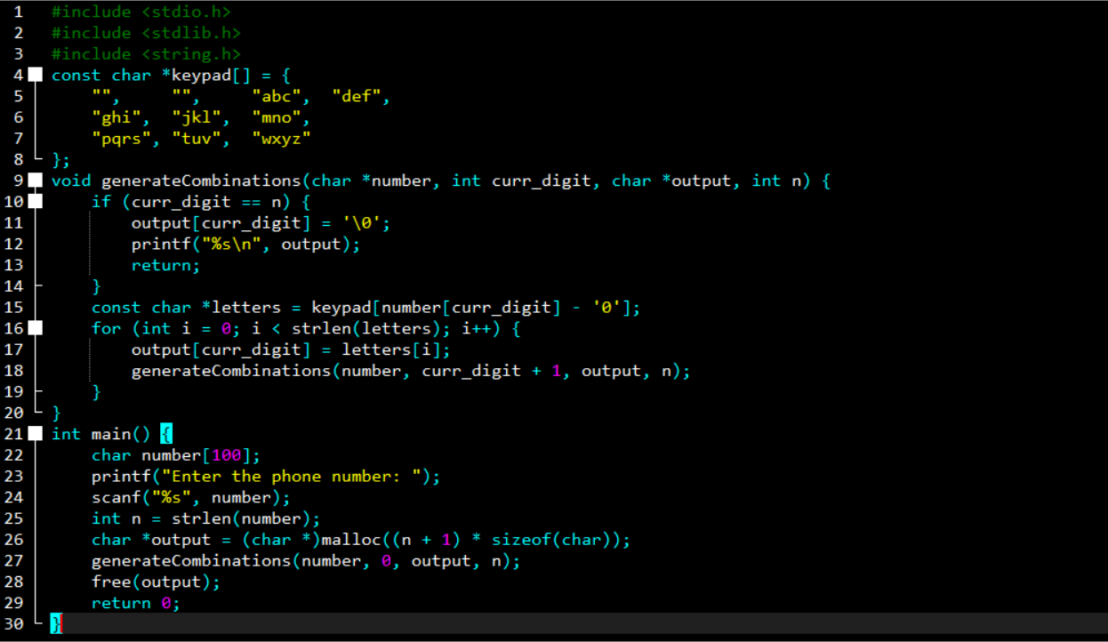

OUTPUT:

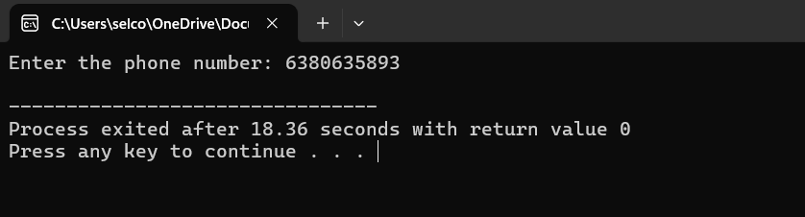

6)4 SUM IN ARRAY OF INTEGERS

CODE:

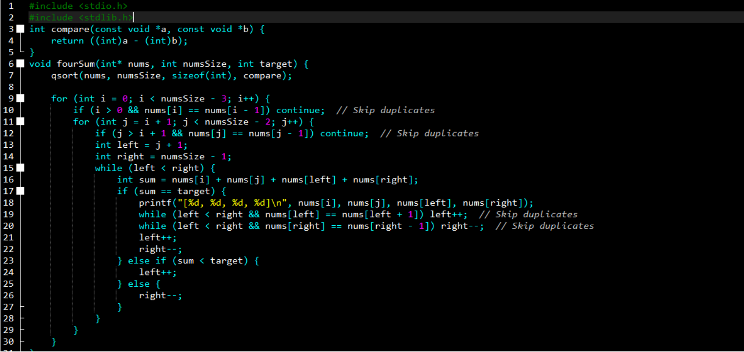

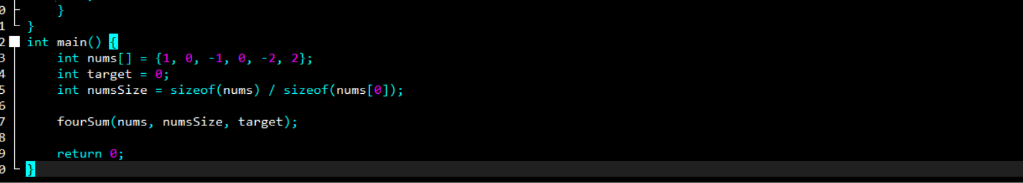

OUTPUT:

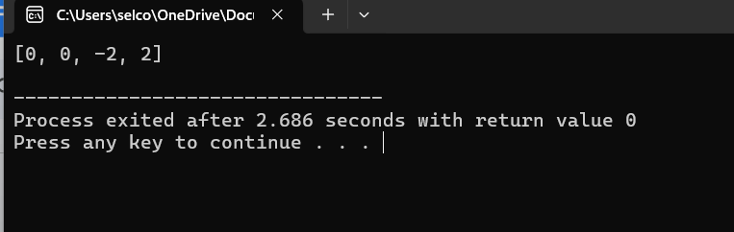

7)REMOVE NTH NODE OF END OF LIST

CODE:

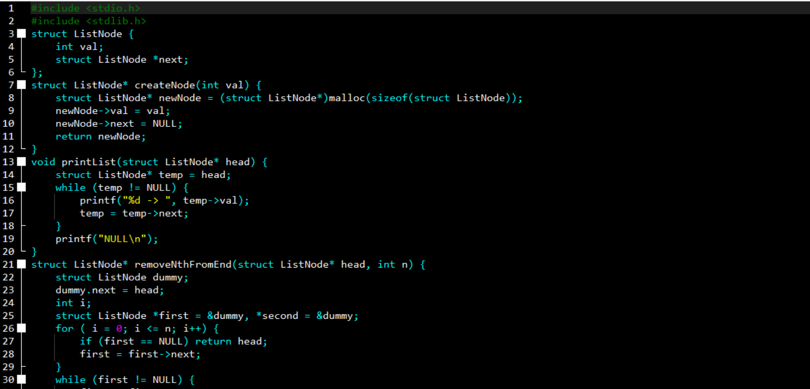

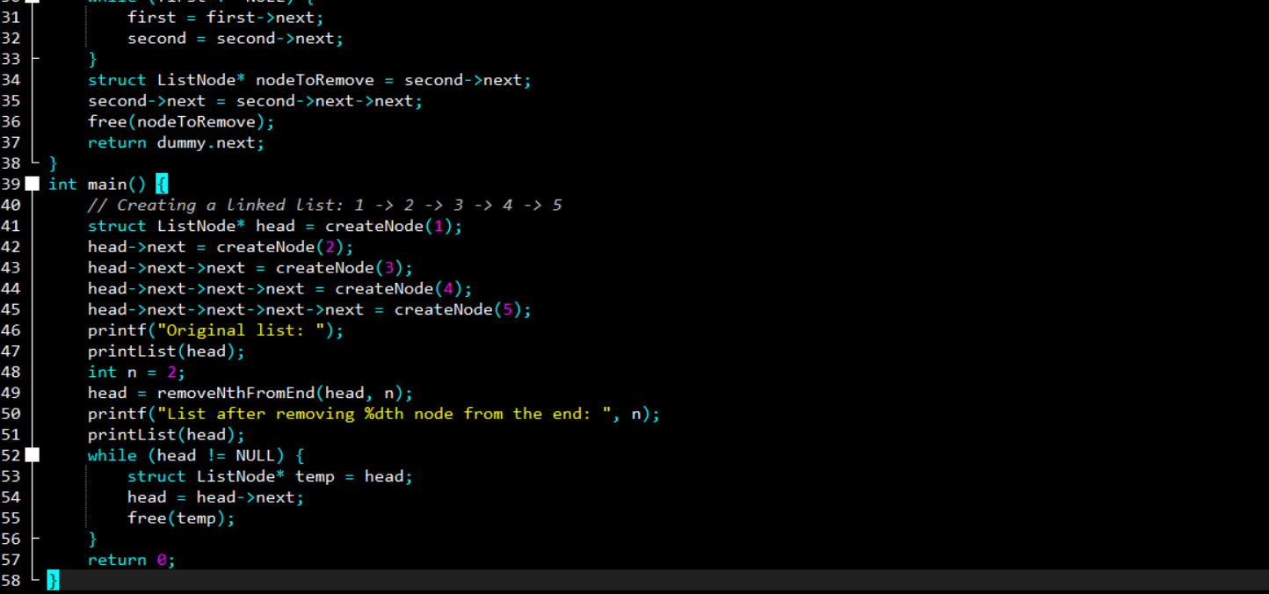

OUTPUT:

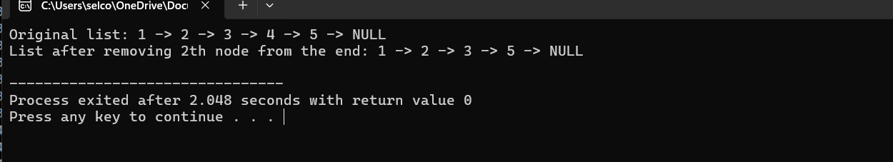

8)VALID PARENTHESSES

CODE:

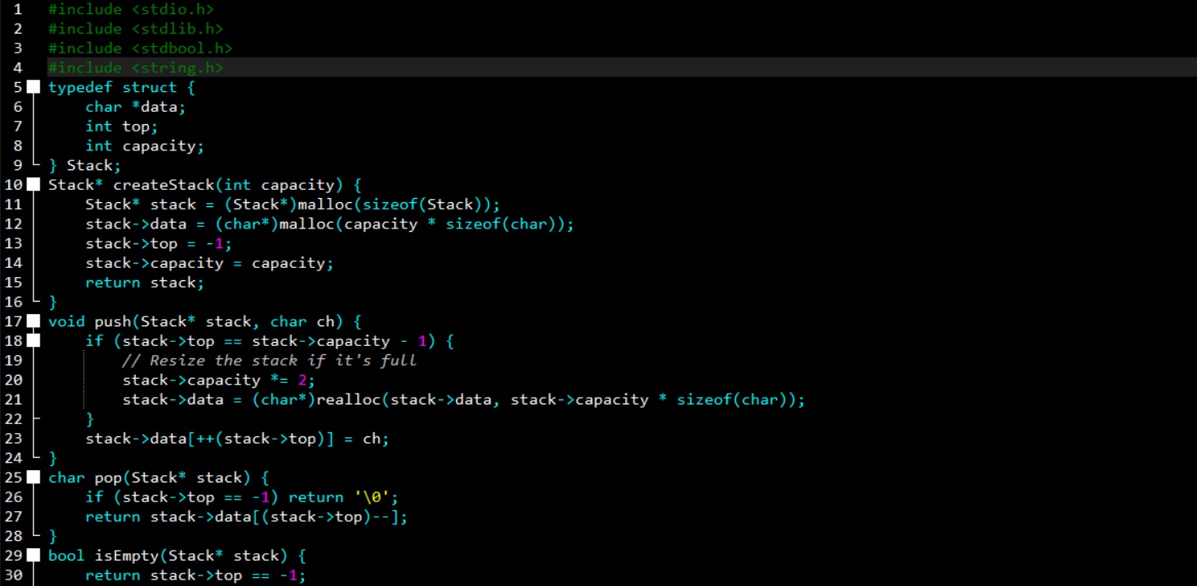

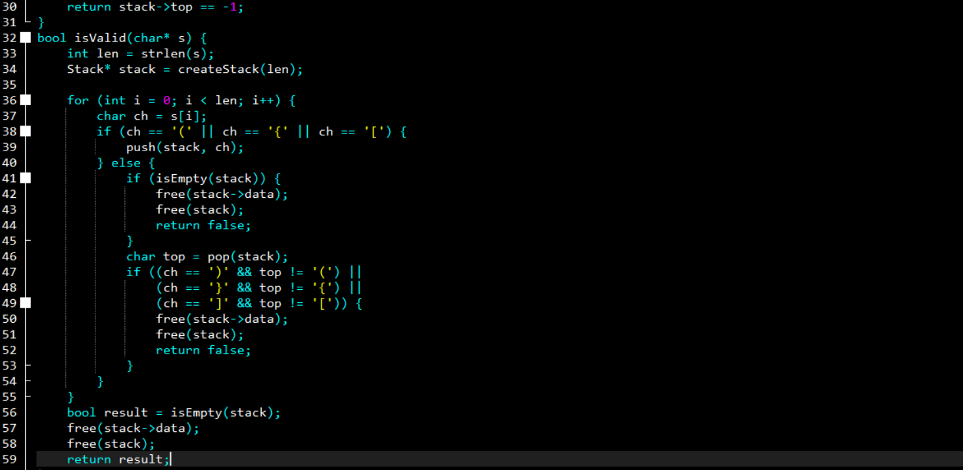

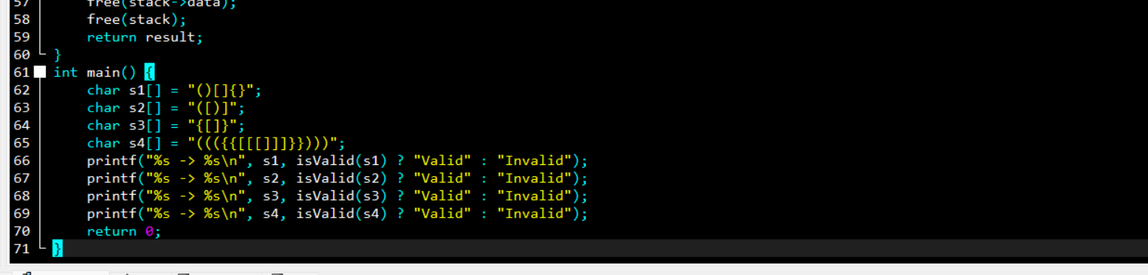

OUTPUT:

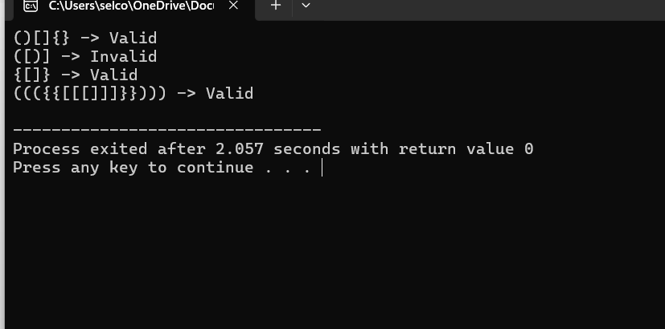

9)3 SUM CLOSEST TO THE ARRAY OF INTERGERS:

CODE:

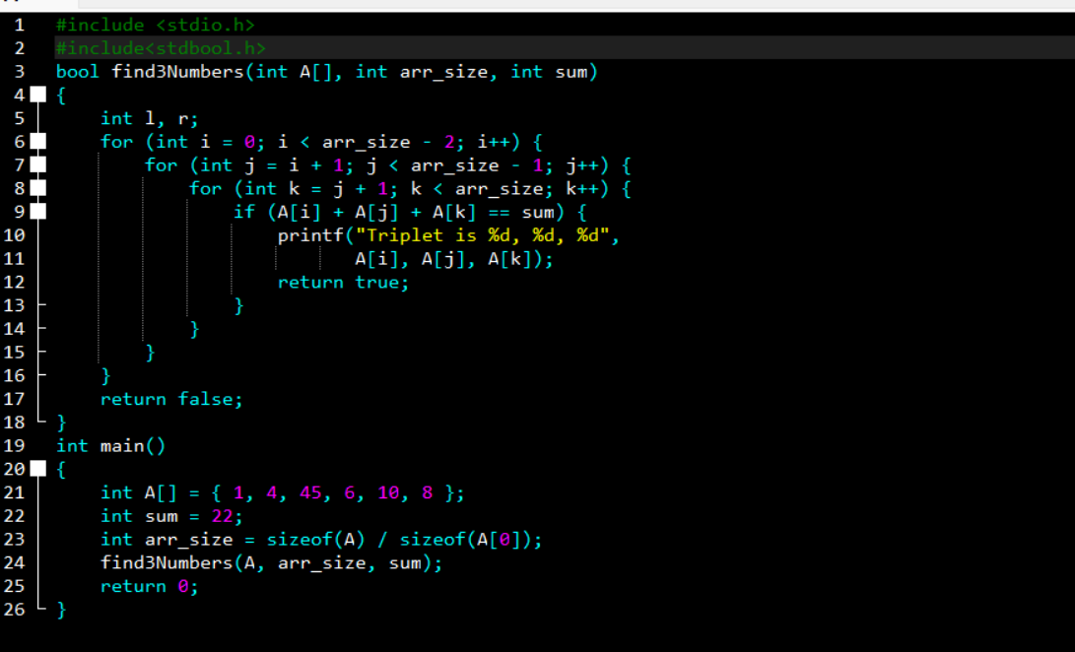

OUTPUT:

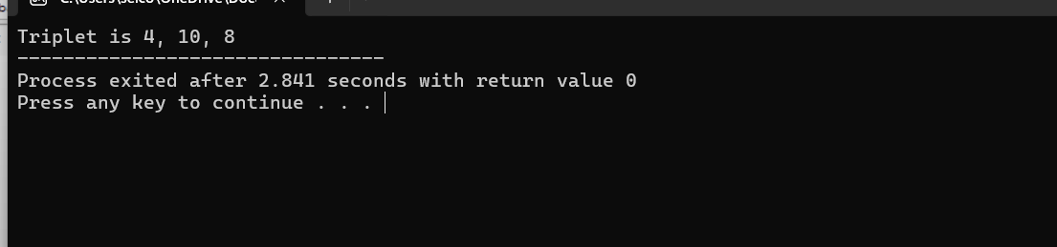

10) CONTAINER WITH MOST WATER

CODE:

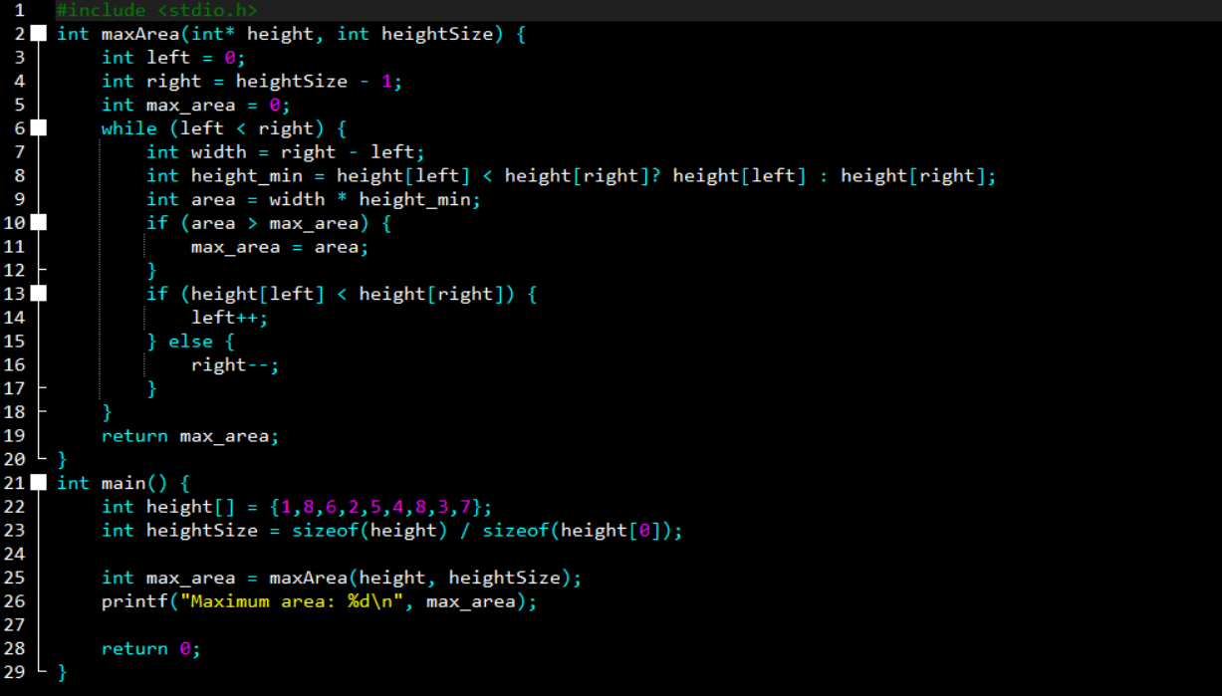

OUTPUT:

